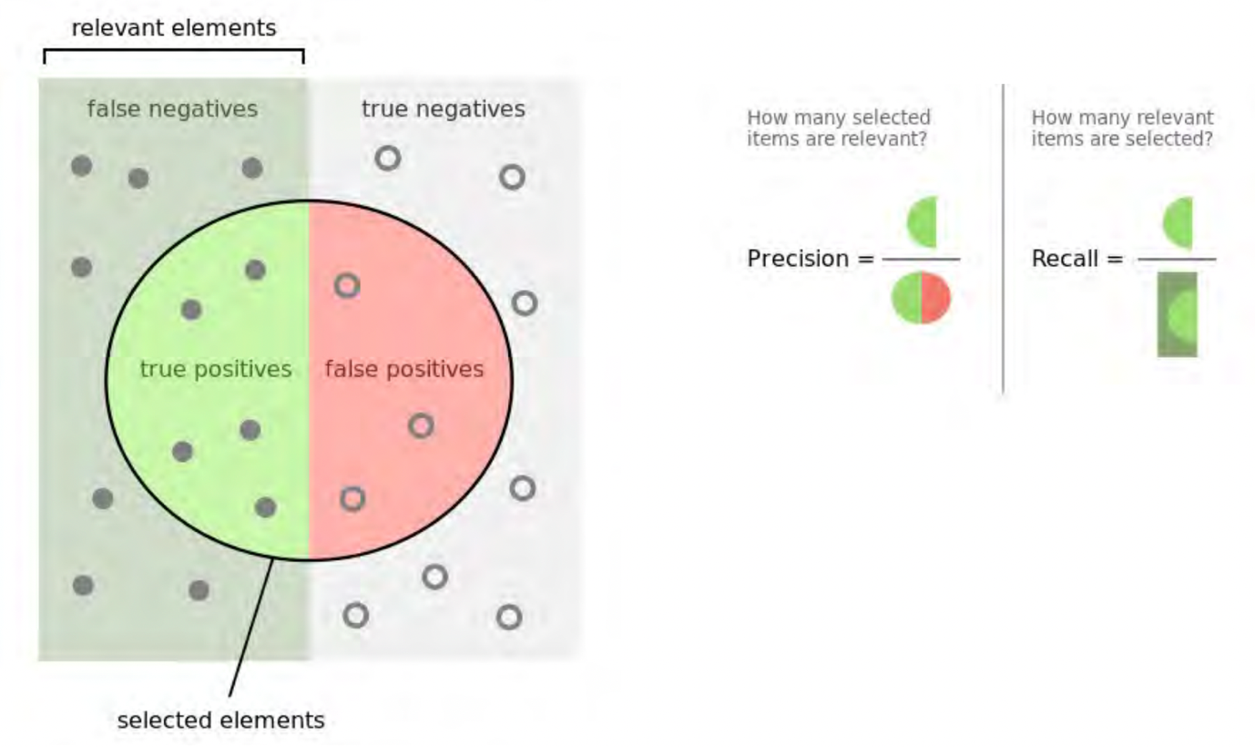

precision = TP/(TP+FP)

recall (sensitivity) = TP/(TP+FN)

decision tree:

* pro:
  + easy to interpret (explicit rule & graphical representation)
  + can handle mixed input (discrete & continuous)
  + robust (outliers & missing values)
  + able to find the most discriminating attributes
  + generally good accuracy
* con:
  + unstable: small changes may lead to a completely different tree
  + can become overly complex

Naïve Bayes

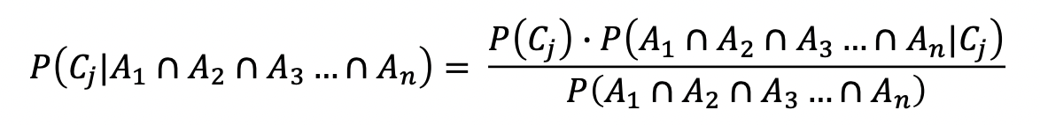

* robust to isolated noise points
* can adapt quickly to new instances (new data)
* handle missing values by ignoring the instance during probability estimate calculations
* robust to irrelevant attributes

**ROC (receiver operating characteristics)**

y:

TFR: true positive rate (recall/sensitivity)

TFR=TP/(TP+FN)

x:

FPR: false positive rate (false alarm)

FPR=FP/(FP+TN)

lift:

a measure of the effectiveness of a predictive model

lift factor= success rate with model/success rate without model